**Objective:** Saving time while testing the Fiori direct access urls with multiple userid. Currently the users testing he GCP urls with multiple users has taking more time. They have to login and logout to test multiple users for a same browser and url.

**Solution:** Chrome Addon required to create new sessions in chrome with Sharing SAP Cookies

**Description:** Currently there are few addons in the chrome web store but it doesn’t have complete features expected

Some of the chrome addons are listed here

<https://www.makeuseof.com/tag/manage-browsing-sessions-google-chrome/>

Similar functionalities available in Firefox

<https://addons.mozilla.org/en-US/firefox/addon/multi-account-containers/?src=search>

<https://addons.mozilla.org/en-US/firefox/addon/temporary-containers/?src=search>

We need create a chrome addon with following functionalities.

1. Need quick option to create a new session or duplicate tab
2. Chrome tab Context Menu should have following option

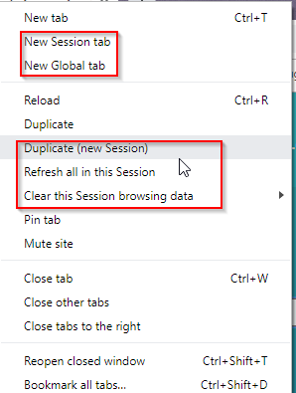

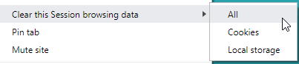

1. Cookies has to be cleared when the last tab of the session is closed
2. Customize options of the extensions

Each session has to be numbered

Each session has to be unique color ..if possible the window color the each session has to be changed

Option to share sap cookies across sessions

**GCP Cookies**

*.cloud.sap

*.hana.ondemand.com

*.ariba.com

*.successfactors.*

*.internal.sde.cloud.sap

*.concursolutions.com

*.fgvms.com

*.s4hana.ondemand.com

**Menu**

Change Menu

1) UX Session -> New Session

New Session (Duplicate)

New Session (Global)

----------------------

Clear All Cookies

Clear GCP Cookies

2) Popup Menu

3) ICON

4) Documentation

5) Chrome addon Name – UX Multi Session -- Done

